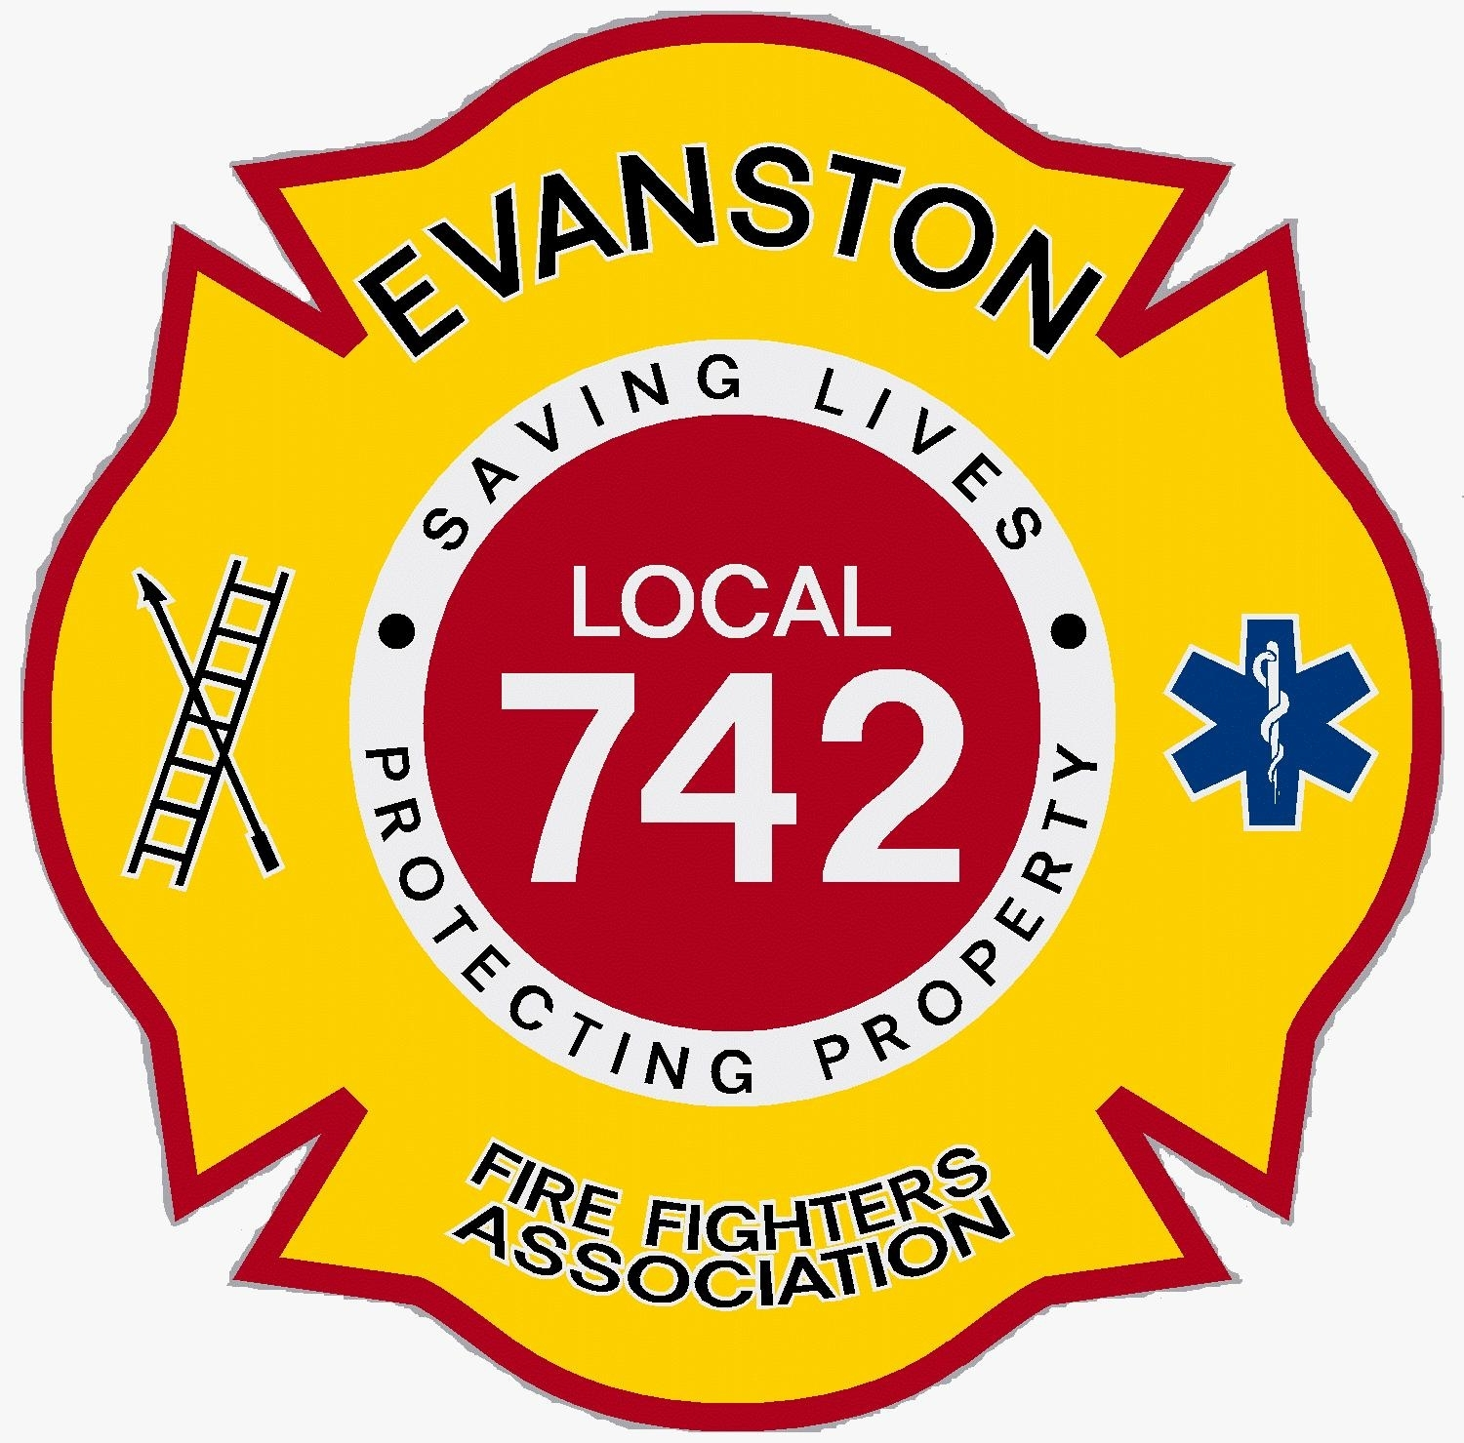 Friends of Firemen’s Park
Engraved Brick Fundraiser Order Form

We are currently having a brick fundraiser for the "Friends of Firemen’s Park". Your name or loved one will be deeply engraved into a brick and will permanently be displayed at Firemen’s Park, located at Simpson and Maple. What a way to leave a lasting impression.
All Proceeds will be used to improve Firemen’s Park

Bronze Level - $100.00
Half Brick (6 3/4” x 4 1/8”) No More Than 3 Lines and 10 Characters per line

First line. Please print in uppercase.

Second line. Please print in uppercase.

Third line. Please print in uppercase.

*NOTE: 10 characters per a line, 3 lines maximum.
*A space counts as a character. Please initial________________

Silver Level - $175.00
Full Brick (6 3/4” x 8 1/4") No More Than 4 Lines and 13 Characters per line

First line. Please print in uppercase.

Second line. Please print in uppercase.

Third line. Please print in uppercase.

Fourth line. Please print in uppercase.

*NOTE: 13 characters per a line, 4 lines maximum.
*A space counts as a character. Please initial________________

Gold Level - $250.00
XL Brick (81/4” x 13 3/4") No More Than 6 Lines and 16 Characters per line

First line. Please print in uppercase.

Second line. Please print in uppercase.

Third line. Please print in uppercase.

Fourth line. Please print in uppercase.

Fifth line. Please print in uppercase.

Sixth line. Please print in uppercase.

*NOTE: 16 characters per a line, 6 lines maximum.
*A space counts as a character. Please initial________________

Name: _ _______________________________ Phone #: ___________________

Address: __________________________________________________________

City: ______________________ State: _________ Zip: ________________

E-Mail: _________________________________________________________

Note: For multiple orders, please staple all orders together and attach payment. Only
one order per order form.

We will continue to take orders throughout the year.

Make checks payable to Friends of Firemen’s Park and mail to:

Friends of Firemen’s Park
c/o Alison Finkel
2127 Maple Ave.
Evanston, IL 60201

Ordering Instructions

- If you wish to purchase additional pavers, please attach additional order sheets. One sheet per brick.
- Your message must fit within the spaces that are not shaded. Spaces between words and names count as characters.
- All text will be standard size, font and style.
- Messages will be centered automatically. No political or religious messages will be accepted and all messages are subject to approval by the Friends of Firemen’s Park Committee.



